Radio Frequency Identification
DAILY TIME RECORD

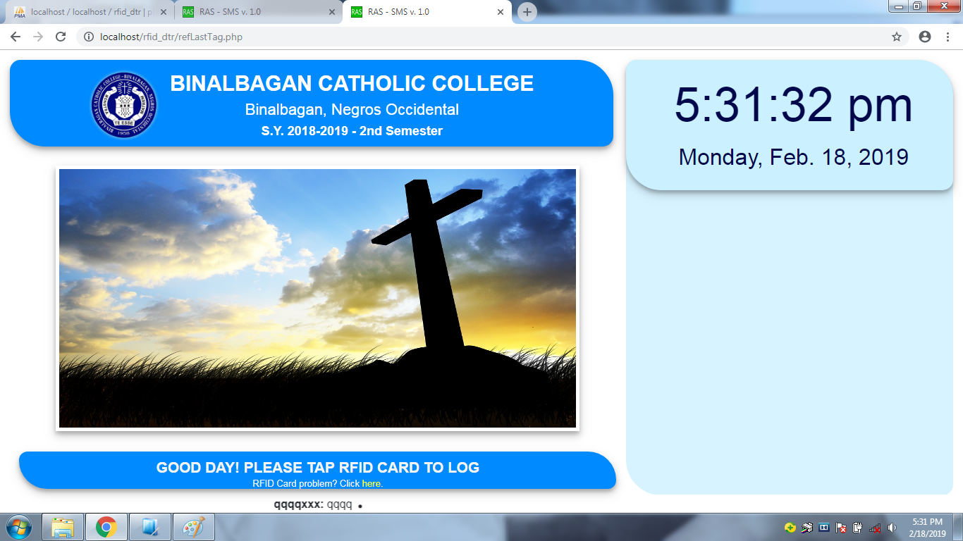

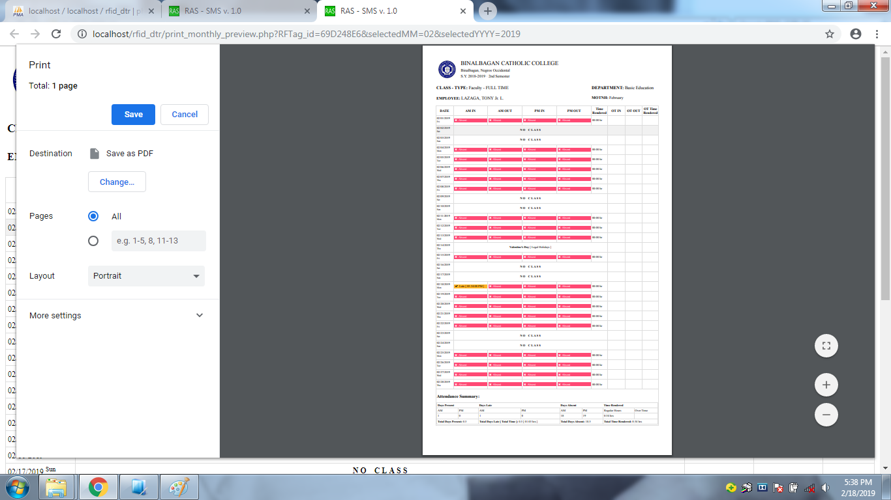

June 14, 2019

HUMAN RESOURCE MANAGEMENT OFFICE
Binalbagan Municipal Hall
Binalbagan, Negros Occidental

Dear Ma’am/Sir,

Good day!

I would like to express my gratitude for the opportunity given to read my proposal.

The overall objective of my proposal is to develop and implement a network-based RFID-DTR System to support the BINALBAGAN MUNICIPAL HALL process in terms of tracking employees’ attendance log records in an automated way.

This system requires low specs of devices and convenient to use because of its user-friendly GUI with centralized data. This system developed through HTML, CSS, and JavaScript as frontend and PHP with MySQL Server as backend integrated with Radio Frequency Identification (RFID) devices.

SYSTEM FEATURES

Network Ready
-easy to setup network

Multiple System Administrator/Users
-easy access of different personnel in-charge
-flexible user dashboard that caters system function to serve paperless processes

Multiple Clients in any Device Platform
- can cater multiple clients that use devices like Personal Computer/Smartphone browsers

Interactive Display
-Employee’s image together with log data
-Slideshow display in client monitor idle time
-Updated news bulletin

National and Municipal Calendar
-this data will reflect in employee’s DTR.

Exact and Detailed Report Output (with CS Form 48)
-Attendance Summary
-Total number of day(s) present/month
- Total number of day(s) late
-with total time late/month
- Total number of day(s) absent/month
- Total daily time rendered with monthly summary
-Includes Legal Holidays & Municipal Activities

SYSTEM HARDWARE SPECIFICATION

Server:
-Computer System with Core i3 processor or higher, 4 GB RAM or higher, Win7/Win10 OS or later
- LCD Monitor, Laser Mouse and Keyboard, and Printer

Client:
-Computer System with Core i3 processor or higher, 4 GB RAM or higher, Win7/Win10 OS or later
- Monitor (preferably touchscreen enabled monitor, else; requires Laser Mouse and Keyboard), and Speaker (optional)

-Extended Client (User Personal Computer (connected to same network with the server)/Smartphone (connected to Wi-Fi with same network with the server)) to browse user dashboard

Equipment and Devices:
Device | Description | Price Range
ACR1281U-C8 RFID Reader | Device that reads the Id tags | Php 5,000.00/unit
RFID Tags (Blank Tags) | Card that has unique tag/code | Php 15.00/pcs
A4Tech HD Webcam | Use to snapshot user in every tap to secure user identity | Php 800.00/unit

*ID printing contractor pricing: 200.00 / per employee (includes Id tags, layout and printing, image & signature capturing)

SYSTEM SOFTWARE SPECIFICATION

Server:
-XAMPP Server
- RFID Reader drivers
-Updated Browser

Client
- RFID Reader drivers
-Webcam Drivers
- Updated Browser

PAYMENT METHOD

The budget of Php 110, 000.00 is the amount of the RFID-DTR System, device not included.

After one (1) month successful system trial, a down payment of Php 50, 000.00 is required after the approval of the proposal and two (2) installments after the installation of the systems.

1st installment – Php 30, 000.00
2nd installment – Php 30, 000.00

A maintenance fee of Php 3, 000.00 pesos per quarter will be collected three (3) months after the six (6) months free maintenance. The maintenance will cover internal system malfunctions or misuse of the systems that will affect the system functions. Additional features to be added will be subject for another proposal.

*Can be upgraded to custom Employee’s Payroll System integrated with the RFID-DTR System as one of its components. Upgrade is applicable in any payment option.
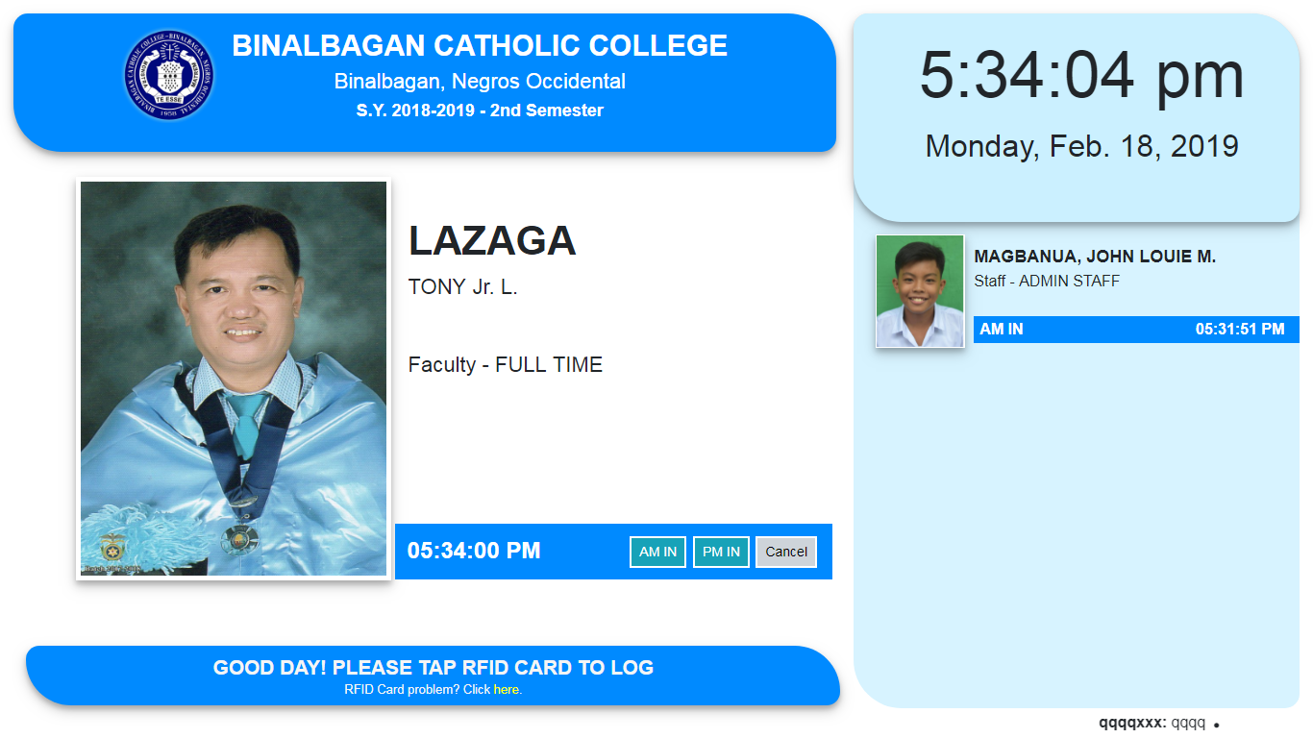
SYSTEM’S SCREENSHOTS
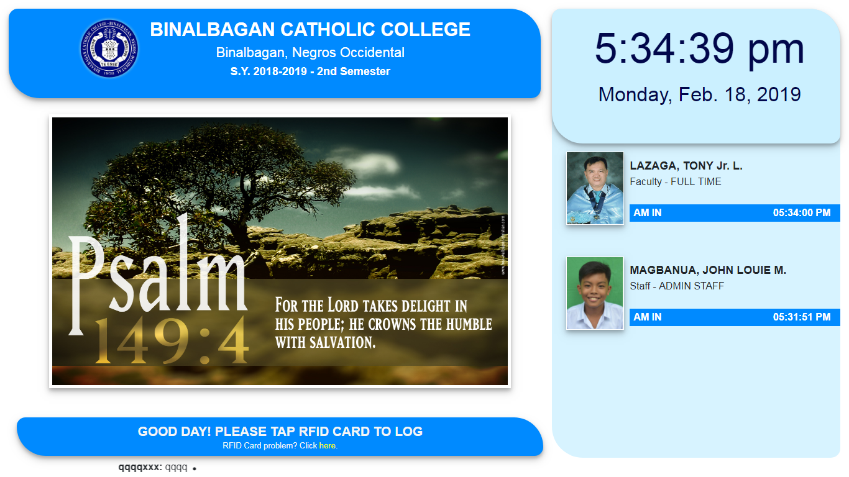
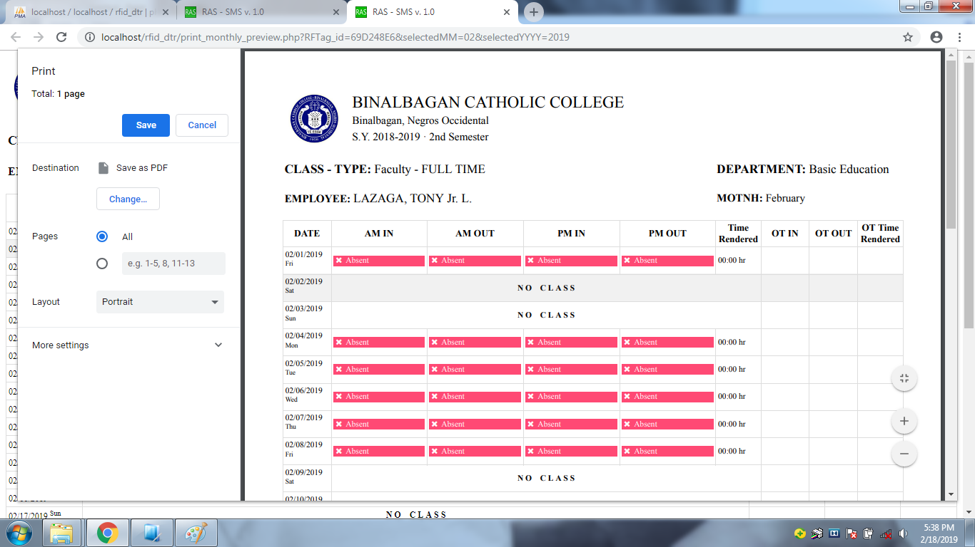

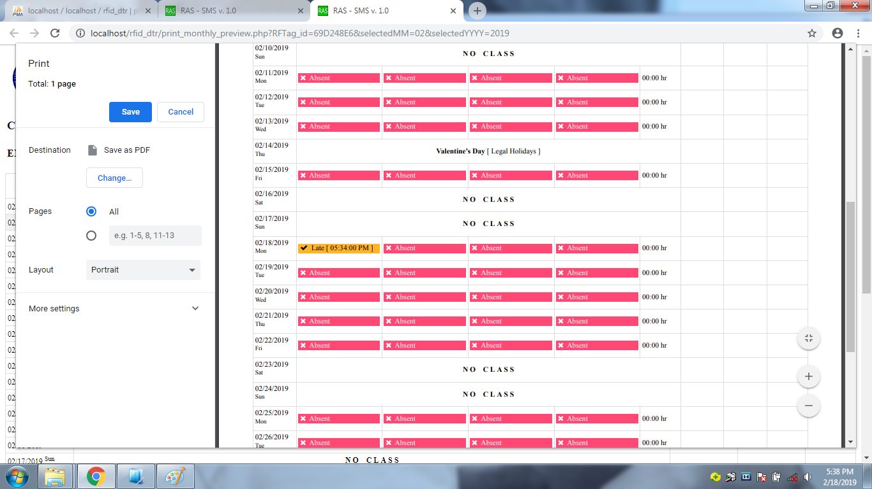

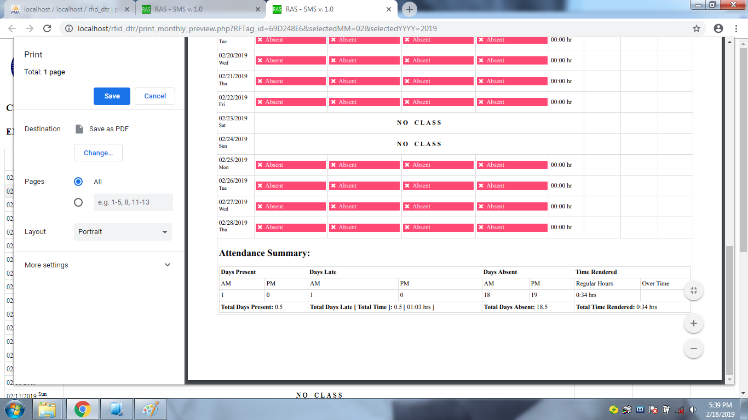

PROJECT REFERENCES

ARIEL B. SOLINA, MIT – BCC Administrative Team, CABAIT Dept. /JHS Instructor (0907-4946964)
LOVELIGHT C. VILLANUEVA, MIT – BCC CABAIT Dept. /SHS Instructor (0930-5355335)

For actual system demonstrations just contact me at 09303546547 two (2) days ahead of time. Thank you!

Respectfully yours,

EMILIO B. MAGTOLIS JR.

